# EXPERIMENT – 3 and 4

|  |
| --- |
| Name: - Arman Bisht |
| Batch – 2 [DevOps Non-Hons] |
| SAP ID- 500093031 |
| Subject – Continuous Integration and Continuous Delivery Lab |

**Aim: Maven Build using GitHub Actions**

1. Push our file on git repo name as CICD-lab3 which contain class file,dockerfile,pom.xml file and so on.

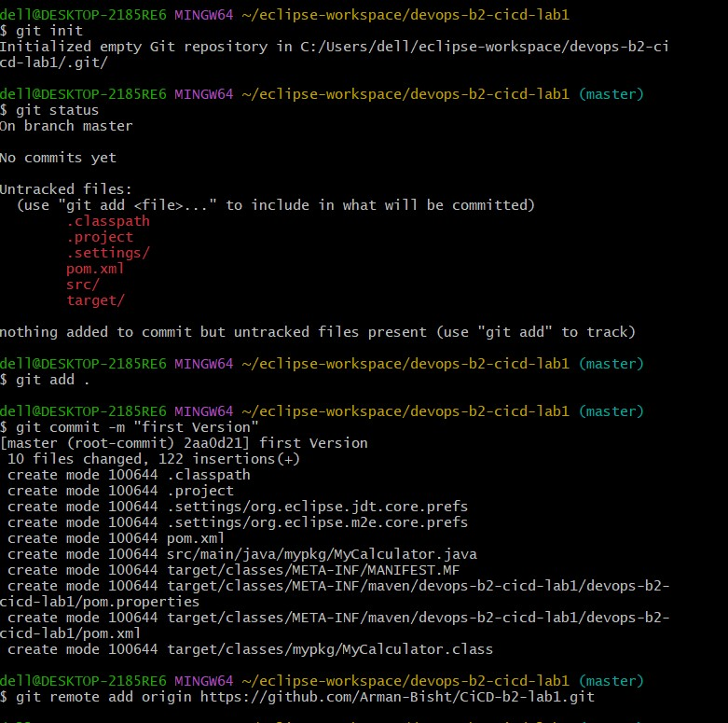

Docker file

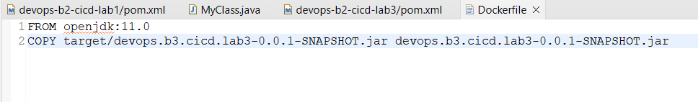

MyClass.java file

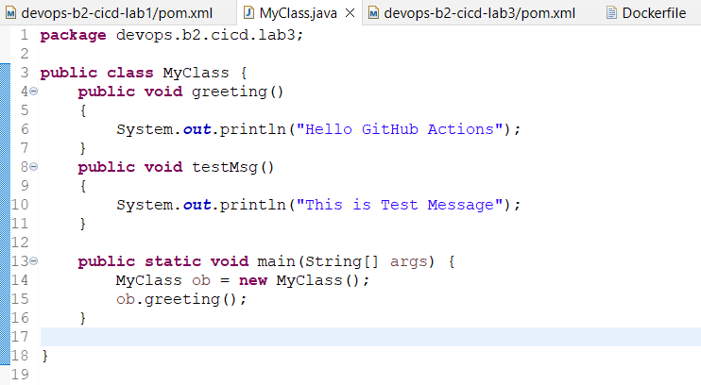

Pom.xml file

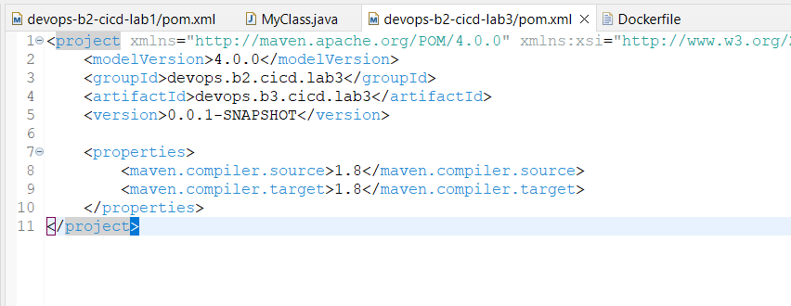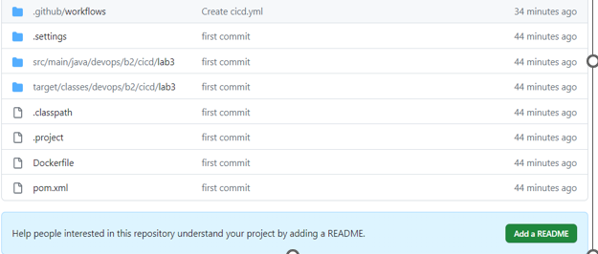

1. **Create a GitHub Actions Workflow name as cicd.yml and click on commit and push changes.**

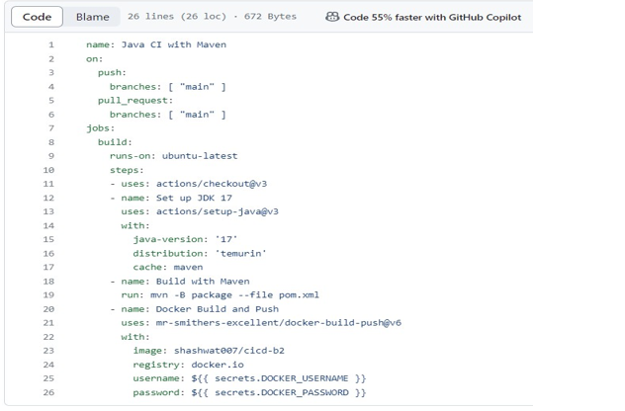

1. **Check the Workflow Status in that you will notices that our build has been completed and build images has been visible in our docker hub .**

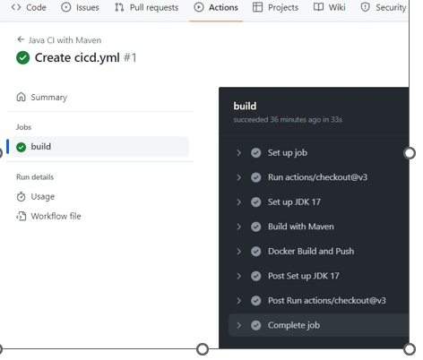

1. **Build image in docker hub**

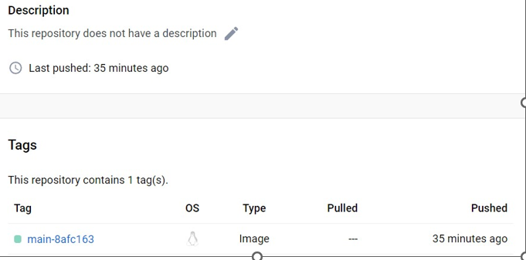

# EXPERIMENT – 4

**Aim : - Docker build and push using Github actions.**

1. **Add Docker Hub Credentials to GitHub Secrets**

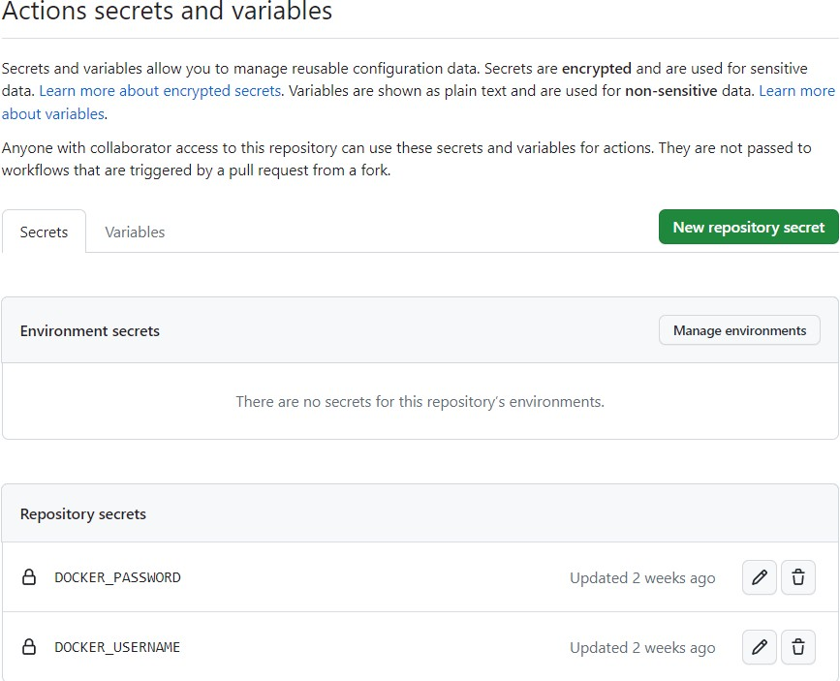

1. **Commit and Push Changes**
2. **Check the Workflow Status in that you will notices that our build has been completed and build images has been visible in our docker hub .**

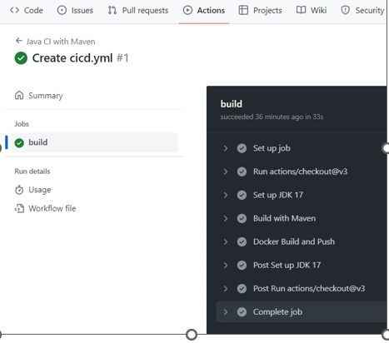

4] Build image in docker hub and docker command in a public view.

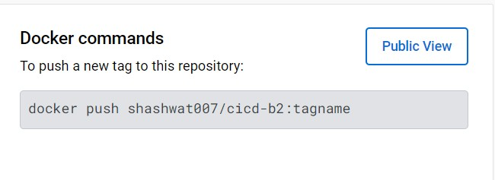

Docker Arman-Bisht cicd-b2:tagname